TCAD-Based Design and Analysis of a Graphene Field-Effect Transistor Biosensor for Malaria Antigen Detection

Archit Agrawal ¹, Shradha Bhatnagar ², Satyendra Kumar Maurya^{1*}, Vishal Saxena ² Dheerendra Singh
¹ Department of Electrical and Electronics Engineering, Birla Institute of Technology and Science, Vidya Vihar, Pilani, Rajasthan 333031, India, Email: f20191048@pilani.bits-pilani.ac.in
² Department of Biological Sciences, Birla Institute of Technology and Science, Vidya Vihar, Pilani, Rajasthan 333031, India
* Corresponding Author
Abstract— Malaria remains a major global health concern, with over 260 million infections and nearly 600,000 fatalities reported in 2024. Motivated by the demand for rapid and low-cost diagnostic technologies, this work introduces a systematic TCAD-based framework for antibody-functionalized graphene field-effect transistor (BioGFET) biosensors targeting malaria antigens. The framework, implemented in Synopsys Sentaurus, leverages its advanced semiconductor-physics solvers and material customization capabilities to model the coupled electrostatic and transport phenomena in liquid-gated BioGFETs. Antibodies and antigen–antibody complexes are represented as charged nano cuboids influencing the channel electrostatics. The simulated device exhibits a linear Dirac point shift (R² = 0.9987), yielding a sensitivity of 13.52 mV/ng·mL⁻¹ and a limit of detection of 14.71 pM. This TCAD-based methodology provides a predictive, physics-driven platform for concept validation prior to device prototyping and experimental characterization, thereby accelerating innovation in portable point-of-care BioGFET diagnostics.
Keywords— Graphene, GFET, BioGFET, antibodies, TCAD simulation, Sentaurus, biosensor, antibody-antigen (Ab-Ag), malaria detection

Introduction
Malaria remains a major global health challenge despite sustained eradication efforts over the past decades. According to the World Health Organization’s 2024 report, an estimated 263 million malaria cases were recorded across 83 endemic countries in 2023, resulting in approximately 597,000 deaths—94% of which occurred in sub-Saharan Africa and 76% among children under five. The recent resurgence of cases, driven by climate change, conflict, and healthcare disruptions, underscores the persistent vulnerability of populations in resource-limited regions [1].
Reliable and rapid diagnosis remains central to malaria control, yet current diagnostic technologies exhibit significant limitations. Microscopy, though considered the gold standard, requires skilled personnel and fails to reliably detect infections with fewer than 50–100 parasites/μL, leading to frequent underreporting [2]. Rapid diagnostic tests (RDTs) based on immunochromatographic assays have gained widespread use due to their portability, low cost, and minimal training requirements. These assays target parasite-specific proteins such as histidine-rich protein 2 (HRP2), aldolase (Aldo), glutamate dehydrogenase (GluDH), and lactate dehydrogenase (LDH). However, they suffer from false positives, poor sensitivity at low parasitemia, antigen persistence, and lack of species specificity—issues that collectively reduce diagnostic accuracy and complicate clinical management. Molecular methods such as PCR, qPCR, and LAMP offer superior sensitivity and specificity but are constrained by their high cost, complex workflows, and dependence on centralized laboratory infrastructure, making them unsuitable for point-of-care deployment in endemic regions.
Graphene field-effect transistor (GFET) biosensors have emerged as a promising alternative for rapid and label-free malaria detection. The two-dimensional nature of graphene ensures that even minute charge perturbations from biomolecular binding events can modulate the channel electrostatics, producing measurable Dirac voltage shifts. Although several experimental GFET biosensors have demonstrated high sensitivity and selectivity, most rely on empirical optimization after fabrication, limiting predictive insights during the design phase.
This study presents a systematic TCAD-based framework for antibody-functionalized BioGFETs targeting malaria antigens, implemented in Synopsys Sentaurus. The use of Sentaurus enables accurate multi-physics modeling of coupled electrostatic and transport phenomena while supporting material customization to represent graphene and bio-functional interfaces. This simulation-driven approach captures antibody–antigen charge interactions, ionic screening, and channel modulation—effects that are challenging to probe experimentally due to variability and cost.
The primary objectives of this work are to (i) develop a validated TCAD workflow for BioGFET simulation incorporating antibody and antigen charge representation, (ii) evaluate device response in terms of Dirac voltage shift, sensitivity, linearity, and detection limit, and (iii) provide design guidelines for optimizing receptor density, electrolyte strength, and device geometry. To the best of our knowledge, this represents the first TCAD-based study of antibody-functionalized GFETs for malaria antigen detection, providing a predictive and pre-fabrication platform to accelerate biosensor innovation.

Simulation Methodology
The simulation study was carried out using Synopsys Sentaurus TCAD, which supports parameterized modeling, drift–diffusion transport simulations, and quantum-corrected electrostatics with adaptive high-density meshing suitable for resolving sub-10-nm charge features. The subsequent section describes the complete workflow and modeling strategy adopted for the BioGFET structure, including the representation of antibody–antigen complexes, electrolyte environment, and the extraction of Dirac voltage shifts.

- Workflow overview of the proposed TCAD-based BioGFET simulation framework

Device Structure & Electrical Modeling
Fig. 2 shows the modelled 3D device. A 3 µm long, 5 µm wide polysilicon channel model representing graphene, adjusted to replicate key physical properties as seen in Table 2 for ambipolar conduction behavior, with an underlying 300 nm SiO₂ layer and gold source and drain electrodes (1 µm × 5 µm, 50 nm thick) atop the channel ends. The reason for choosing 3 µm is that a 3 µm channel lies in a middle regime offering saturation‑like behavior, good transconductance, and manageable series resistance all while being reliably implementable via photolithography [7].
While polysilicon was parameterized to mimic graphene’s high carrier mobility and ambipolar conduction, it is acknowledged that this surrogate does not fully capture graphene’s unique zero bandgap, quantum capacitance, and surface chemistry. To validate our approximation, the simulated pristine BioGFET transfer characteristics curve was compared against reported experimental GFET transfer characteristics curves from CVD-grown devices [19]. Nevertheless, effects such as charge puddling, edge states, and quantum capacitance remain unaccounted for, which may introduce deviations when extrapolating to experimental conditions.
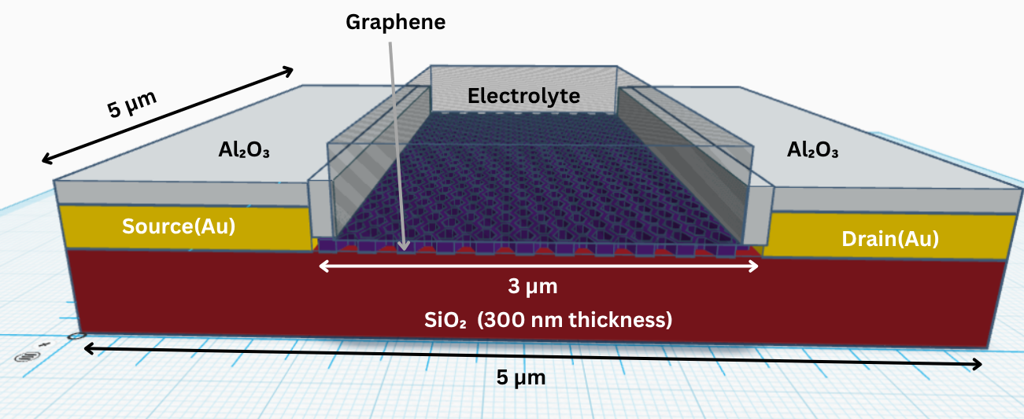
- 3D representation of the modelled BioGFET

- Dimensions of the modeled Bio-GFET
Parameter | Value
SiO₂ Length/Width | 5 μm/5 μm
Channel Length (L) | 3 μm
Channel Width (W) | 5 μm
SiO₂ thickness | 300 nm
Polysilicon (Graphene) thickness | 5 nm
Metal contact Length | 1 μm
Metal contact Width | 5 μm
Au thickness | 50 nm
Electrolyte thickness | 100 nm
Al₂O₃ thickness | 100 nm
- Material parameters of Graphene used to model GFET [11][12][13]
Parameter | Description | Value
Eg | Bandgap | 10⁻⁴ eV
ε | Permittivity | 25
μ_{n} | Electron mobility | 10000 cm²/V·s
μ_{p} | Hole mobility | 10000 cm²/V·s
V_{sat} | Saturation velocity | 4x10⁷ cm/s
𝛘 | Electron affinity | 4.248 eV
- Material parameters of (0.001X) diluted PBS solution used in GFET
Parameter | Description | Value
Eg | Bandgap | 1.5 eV
ε | Permittivity | 80
μ_{n} | Electron mobility | 6.88x10⁻⁴ cm²/V·s
μ_{p} | Hole mobility | 4.98x10⁻⁴ cm²/V·s
𝛘 | Electron affinity | 3.9 eV
τ_{n} | Recombination lifetime electron | 10⁻³ s⁻¹
τ_{p} | Recombination lifetime hole | 10⁻³ s⁻¹
N_{v} | hDOSMass | 1.4326x10²⁹ cm⁻³
N_{c} | eDOSMass | 1.4326x10²⁹ cm⁻³
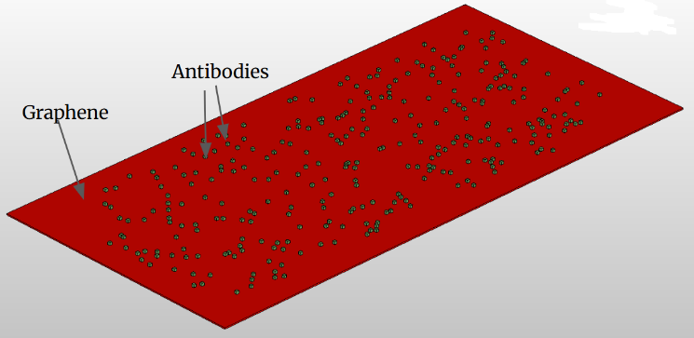
- Graphene surface with 300 antibodies randomly placed.

Aluminum oxide is used to encapsulate the metal contact. Surrounding the 100 nm slab of liquid-gated electrolyte representing (0.001×) diluted PBS solution (pH 7.4), modeled with permittivity ≈ 80, low carrier mobility, and appropriate intrinsic carrier concentration to simulate Debye‑layer effects.
The diluted PBS electrolyte is not available in the Sentaurus material library; therefore, an intrinsic semiconductor was defined with modified parameters to emulate the electrolyte properties, as listed in Table 3. [6][9][10].
Electrons and holes were simulated using the drift–diffusion transport model under room-temperature conditions. A constant drain‑source voltage of 50 mV was applied, while gate voltage was swept from –1 V to +2 V (step size 1 mV) to obtain the transfer characteristics (ID vs VG). The Dirac voltage for each antigen condition was identified as the gate voltage corresponding to the minimum channel conductance.

Antibody Modeling
Each immunoglobulin G (IgG) antibody was represented as a cuboid of dimensions 12 nm × 12 nm × 3 nm, positioned 2 nm above the graphene surface to mimic the linker region (e.g. PBASE) previously reported in AFM‑based measurements [14]. The height corresponds to the Fc–Fab region excess in the “upright” receptor orientation. Published literature and zeta‑potential studies place the isoelectric point of IgG around 6.1–8.5, and at pH 7.4 most antibodies retain net positive surface charge (~+4e) on the paratope region of the Fab arms [15].
This yields a uniform volumetric charge density of ~9.26 × 10¹⁸ e/cm³ assigned to each antibody cuboid. A total of 300 antibody units were randomly distributed across the channel area (~2 × 109 Abs/cm²), ensuring non-overlap under periodic boundary conditions to mimic realistic receptor densities from the literature. These distributed antibodies over graphene is shown in Fig. 3.

Antigen Binding & Ab–Ag Complex Modeling
A Plasmodium falciparum hypothetical protein epitope i.e., DSEEKEEQGQKPEKV – was chosen based on its antigenic propensity. The epitope has an approximate net charge of –3e at physiological pH (calculated using standard amino acid pKa values and terminal group contributions as shown below). This charge was calculated using tools such as Pepcalc, Bachem Peptide Calculator, and NovoPro Peptide Property Calculator NovoPro Labs by calculating the charge on peptide sequence “DSEEKEEQGQKPEKV” of antigen at pH 7.4. For this, we need to consider the ionizable groups within the peptide and their respective pKa values.
Ionizable Groups in my peptide:
- N-terminal amino group: Typically has a pKa around 8.0. At pH 7.4, it's mostly protonated, contributing +1e charge.
- C-terminal carboxyl group: Typically has a pKa around 3.1. At pH 7.4, it's deprotonated, contributing -1e charge.
- Side chains of ionizable amino acids:
- Aspartic acid (D): pKa ≈ 3.9; deprotonated at pH 7.4, contributing -1e charge.
- Glutamic acid (E): pKa ≈ 4.1; deprotonated at pH 7.4, contributing -1e charge each.
- Lysine (K): pKa ≈ 10.5; protonated at pH 7.4, contributing +1e charge each.
Charge in my peptide:
- N-terminal amino group: +1e
- C-terminal carboxyl group: -1e
- Aspartic acid (D): 1 residue × (-1) = -1e
- Glutamic acid (E): 4 residues × (-1) = -4e
- Lysine (K): 2 residues × (+1) = +2e
Total Net Charge = (+1e) + (-1e) + (-1e) + (-4e) + (+2e)
= -3e
The net charge of the peptide DSEEKEEQGQKPEKV at pH 7.4 is -3e. Here, 1e charge means charge on 1 electron ~ 1.602 x 10-19 C.
When an antigen binds to an antibody with net +4e, each Ab–Ag complex retains a net +1e, and is modeled as a 12 nm × 12 nm × 8 nm cuboid to accommodate the antigen’s physical size (~5 nm extra height). The resulting volume charge density is ~8.68 × 10¹⁷ e/cm³. During simulation, 0 to 300 antibodies were gradually replaced by Ab–Ag complexes at specified target ratios (0, 50, 100, 200, and 300), representing incremental antigen concentrations.
Charges were uniformly distributed across each cuboid, ensuring that the effective charge lies within the Debye length (~9.6 nm) and thus influences the channel electrostatics.

Implications of Debye Length Engineering
To examine the influence of ionic strength on sensor performance, simulations were conducted under two electrolyte conditions: 1× PBS (physiological ionic strength) and 0.001× PBS (highly diluted). In related experimental GFET biosensor studies, 0.001× PBS has been shown to yield a Debye screening length of approximately 24 nm—sufficient for the charges of antibody–antigen complexes to modulate the graphene channel. In contrast, 1× PBS exhibits a Debye length of less than 1 nm, resulting in strong electrostatic screening of surface charges [20].
In the present simulations, under 1× PBS, the surface charges from antigen–antibody complexes induce only minor Dirac point shifts (a few millivolts) due to this strong screening, whereas under 0.001× PBS, significantly larger shifts are observed, consistent with previously reported experimental trends [20].

Simulation Execution and Curve Separation
Each antigen scenario (0, 50, 100, 200, 300 Ab–Ag complexes) was simulated independently, with identical random distributions for antibodies or antigens sites. Transfer curves (ID vs VG) were collected and their minima (Dirac voltages) extracted.

Results and Discussion
Initial simulations of the pristine GFET revealed ambipolar transfer characteristics (Figure 4) with a Dirac point near 0.588 V under a drain-source bias of 50 mV. This behavior aligns with theoretical expectations for GFETs, where the
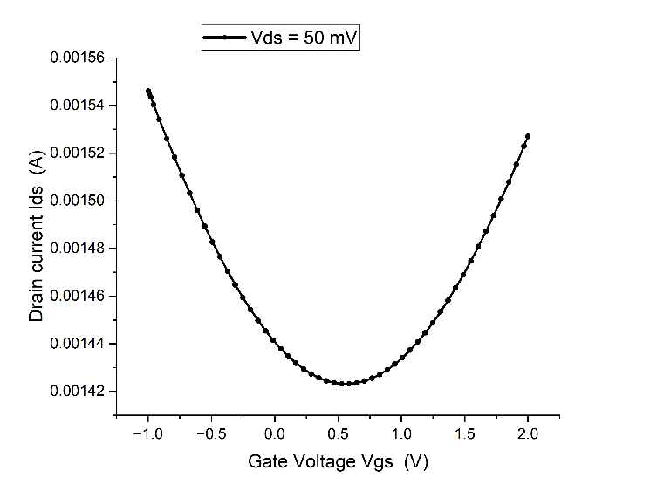
- Transfer characteristics curve for Drain voltage(V_{DS}) = 50 mV
charge neutrality point occurs at the Dirac voltage. The symmetrical curve around the Dirac point confirms the successful modeling of the graphene-like channel.
While the simulated ambipolar transfer characteristics validate that the polysilicon channel captures key graphene-like behavior, it is important to note that this surrogate cannot reproduce certain intrinsic graphene phenomena. Specifically, effects such as quantum capacitance, charge puddling, edge disorder, and interfacial dipole interactions are absent in this framework. These factors are known to influence real GFET transfer characteristics, particularly near the Dirac point. Consequently, although the observed Dirac voltage shifts and linearity trends are reliable for design guidance, the absolute sensitivity and detection limit values should be interpreted as optimistic upper bounds rather than direct predictions of experimental performance.
Figure 5 shows the transfer characteristics curve where immobilizing 300 IgG cuboids shifts the Dirac point leftward by ~0.06 V, reflecting n-type gating induced by positive surface charge. The corresponding values are summarized in Table IV.
Multiple random spatial distributions of antibodies were simulated with a fixed number of bound molecules. The resulting I–V characteristics showed strong overlap across all cases, confirming that the device response is statistically invariant to receptor spatial randomness. However, additional studies are needed to understand the variability observed in experimental measurements.
Figure 6 overlays transfer curves for increasing Ab–Ag complexes (0–300), each offset by 0.1 V for clarity. The Dirac point progresses from 0.526 V (0 complexes, i.e., 300 bare antibodies) to 0.590 V (300 complexes). These values are listed in Table V.

- Dirac points for different values of antibodies according to graph
Antibodies | Dirac Point(V)
0 | 0.58845333
300 | 0.52845333

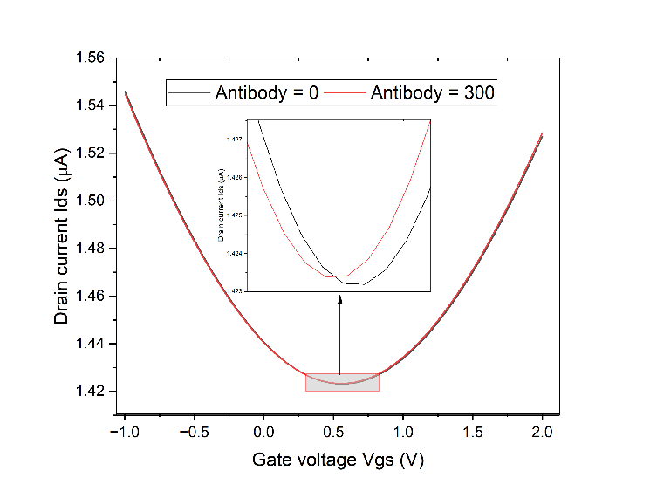
- Transfer characteristics graph for simulated nano-biosensor for graphene without antibodies and with 300 antibodies. Values shown in Table IV
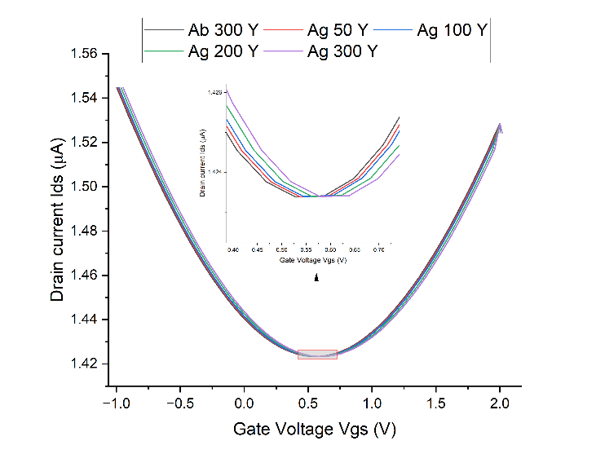
- Transfer characteristics graph for simulated nano biosensor for different values of number of Ab-Ag complex, where Ab 300 denotes the graph when graphene is functionalized at 300 Ab and Ab 50 denotes that 50 antigens have bound to 50 antibodies out of 300 antibodies. Values shown in Table V
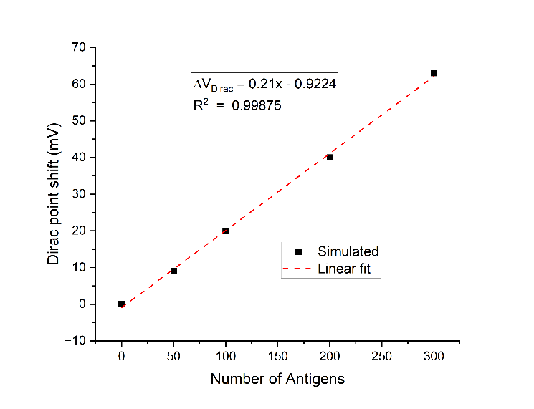
- Variation of the Dirac point voltage (ΔV_{Dirac}) as a function of the number of antibodies–antigen (Ab–Ag) complexes (represented by symbols) or it can be said to be number of antigens, along with the corresponding linear fit (dashed line). The graphene surface was pre-functionalized with 300 randomly distributed antibody receptors.
- Dirac points for different values of ab-ag complex according to graph
Ab-Ag | Dirac Point (V)
0 (Ab 300) | 0.5264
50 | 0.536
100 | 0.545
200 | 0.566
300 | 0.590

Figure 7 plots the Dirac point shift (ΔV_{Dirac}) as a function of the number of Ab–Ag complexes, showing a clear linear relationship with regression fit R² = 0.9987. Importantly, this “excellent fit” refers to the regression of simulated data rather than experimental validation.
To assess reproducibility, additional simulations with random antibody–antigen spatial distributions were performed. At 50 complexes, the Dirac shift averaged ~0.010 V with a variability of ±2 mV across five random placements. At higher antigen numbers (>200 complexes), variability reduced to less than ±5% of the mean shift, indicating that spatial distribution effects are most critical at low antigen concentrations.

Performance Parameters
Based on the above results, key sensor performance metrics were evaluated and are summarized below along with relevant literature comparisons.
- Sensitivity:
From the regression of Dirac point shift versus antigen–antibody complex number (Fig. 7), the device exhibits a sensitivity of ~0.21 mV per complex. When mapped to antigen concentration, this corresponds to an effective sensitivity of ≈13.52 mV/ng·mL⁻¹ (Equations 1-6).
ΔV_{Dirac} =0.21—0.9224 mV, R²=0.9987 (1)
where x is the number of bound antibody–antigen (Ab–Ag) complexes. Thus, the device exhibits a sensitivity of 0.21 mV per complex.
To translate this into a more conventional concentration unit (mV per ng/mL of AMA1 epitope of malaria antigen), we first estimate 300 Ab–Ag complexes equals how much ng/mL AMA1
Molecular weight of AMA1 domain III is 14 kDa (14 000 g/mol). [16]
Mass per antigen molecule:
$$\frac{14,000 g/mol}{6.022×10^{23} molecules/mol} = 2.33×10 -20 g (2)$$
Total mass for 300 molecules:
$$300×2.33X10^{-20} =6.99×10^{-18} g (3)$$
Active area = 3 µm x 5 µm = 15 µm²
Effective height = 100 μm
Assumed sensing volume: Active area x Effective height =
$$15 μm^{2} X 100 µm ≈ 1.5X10^{-12} L (4)$$
Corresponding concentration:
$$\frac{6.99X10^{-18} g}{1.5X10^{-12} L} = 4.66 X 10^{-6} g/L = 4.66 ng/mL (5)$$
Using this mapping, 300 complexes ↔ 4.66 ng/mL, the slope of 0.21 mV/complex converts to:
$$0.21\frac{mV}{complex} X \frac{300 complexes}{4.66 ng/mL} = 13.52 \frac{mV}{ng/mL} (6)$$
Thus, the BioGFET achieves an effective sensitivity of ≈ 13.52 mV per ng/mL of AMA1 antigen.
The translation from “per complex” to “per ng/mL” depends on the assumed sensing volume. If the effective sensing height is varied from 50 µm to 150 µm instead of 100 µm, the calculated sensitivity shifts from ~20.3 mV/ng·mL⁻¹ (smaller volume) to ~10.1 mV/ng·mL⁻¹ (larger volume). Similarly, if the antigen molecular weight is 10% higher or lower than the assumed 14 kDa, the derived sensitivity changes by ±10%. These results indicate that while the linear relationship between ΔV_{Dirac} and antigen number is robust (modeled), the conversion to ng/mL carries uncertainty from geometric and biochemical assumptions (inferred).
It should be noted that the concentration mapping depends on assumptions of sensing volume and antigen molecular weight. For example, varying the effective sensing height between 50–150 µm changes the calculated sensitivity by nearly a factor of two, while a ±10% change in antigen molecular weight leads to proportional variation. Thus, while the linearity of ΔVDirac is robust, the conversion to ng·mL⁻¹ carries geometric and biochemical uncertainty.
- Variability Analysis:
To assess reproducibility, additional simulations with random antibody–antigen spatial distributions were performed. At 50 bound complexes, the Dirac point shift averaged ~0.010 V with a variability of ±2 mV across five random placements. At higher antigen numbers (>200 complexes), variability reduced to <5% of the mean shift, suggesting that spatial distribution effects are most critical at low analyte concentrations.
This preliminary analysis can be interpreted as a simplified Monte Carlo approach, where receptor positions are randomized across multiple runs to estimate variability. Extending this framework to incorporate additional stochastic factors—such as charge fluctuation noise or partial receptor occupancy—would allow a fuller Monte Carlo–based variability analysis. Even at this preliminary stage, the results indicate that the device response is relatively robust to receptor placement randomness, though further stochastic modeling is recommended for improved predictive fidelity.
- Limit of Detection (LOD):
According to the IUPAC Compendium of Analytical Terminology, the limit of detection (L_{d} or LOD) is defined as the smallest analyte quantity or signal that can be detected with reasonable statistical certainty above the background noise of a blank measurement [17]. Mathematically, this is expressed as:
$$L_{d}​ =\underline{S} _{blank} +k⋅σ_{blank}​ (7)$$
Where S_{blank} is the mean blank signal (e.g. Dirac voltage
with no antigen bound), σ_{blank} is the standard deviation of repeated blank measurements, and k is the confidence factor (typically 3) [17].
From the pristine‑graphene simulations, Mean blank Dirac voltage (𝑉_{Dirac},0) is equivalent to 0.526 V and baseline standard deviation (𝜎_{Dirac},0) is equivalent to 1 mV, estimated from repeated baseline simulations. Thus, the minimal detectable Dirac shift (signal threshold) is:
$$L_{d}​ \left(Dirac\right)=0.526 V+3×0.001 V (8)$$

$$L_{d}​ \left(Dirac\right)= 0.529 V (9)$$
Which means that any Dirac shift greater than ~3 mV above the baseline is statistically discriminable from the blank.
Therefore, minimum detectable number of complexes (x_{LOD}):
$$x_{LoD} =\frac{3 mV}{0.21 mV/complex} ≈14 complexes (10)$$
Converting complexes into concentration:
$$C_{LoD} = \frac{14}{300}× 4.66\frac{ng}{mL}≈ 0.22\frac{ng}{mL} \left(11\right)$$
Using equations (7–11), the LOD is ~0.22 ng/mL, equivalent to ~14 Ab–Ag complexes. At this concentration, the simulated ΔV_{Dirac} is ~3 mV above baseline, which is resolvable within the simulation framework.
Converting LOD to M(mol/L):
$$LOD = \left(0.22×{10}^{-6} \frac{g}{L}\right)÷14,000\frac{g}{mol} = 15.71 pM \left(12\right)$$
In practice, however, the experimental LOD may be higher due to low-frequency flicker noise (~2–5 mV RMS in similar GFETs). Since the simulated threshold (≈3 mV) lies close to this noise floor, the reported LOD should be considered an optimistic lower bound, with real devices expected to exhibit slightly reduced detectability.
- Linearity:
The ΔV_{Dirac} response shows nearly perfect proportionality to antigen concentration (R² = 0.9987) under 0.001× PBS, making quantitative calibration feasible. This high linearity is a modeled outcome; in real devices, deviations may occur due to receptor saturation, nonuniform coverage, or background drift.
- Response Time:
Dynamic binding kinetics were not explicitly simulated. However, based on drift–diffusion timescales and reported antibody–antigen association rates, the estimated sensor response time is in the range of 5–10 s, consistent with experimental observations in GFET biosensors [18]. This represents an inferred value rather than a directly modeled parameter.
- Noise Analysis and Practical Detectability:
Noise was not included in the TCAD framework, but literature suggests two primary contributions:
- Thermal noise: <0.1 mV RMS in 1 Hz bandwidth, negligible compared to signal.[21]
- Low-frequency flicker noise (1/f): typically 2–5 mV RMS for GFETs of similar area, dominating the noise spectrum.
To contextualize detectability, it is important to compare the simulated signal magnitude against realistic device noise. In graphene FETs of comparable dimensions, low-frequency flicker noise typically ranges between 2–5 mV RMS [21], which is of the same order as the modeled Dirac voltage shift at the LOD (~3 mV). This proximity implies that practical detection will require noise-reduction strategies such as lock-in amplification, baseline stabilization, or differential referencing. Accordingly, the simulated LOD of ~0.22 ng/mL should be interpreted as an optimistic lower bound, with experimental devices expected to exhibit slightly reduced sensitivity due to noise floor limitations.

Comparison with Experimental Malaria Biosensing Benchmarks
Although our simulations align qualitatively with published GFET transfer curves, direct comparison with malaria biosensing is limited. Clinically, plasma PfHRP-2 levels in malaria patients can reach hundreds of ng/mL (mean ~840 ng/mL) in symptomatic cases [23]. In malaria immunosensors, a sandwich immunoassay format achieved an LOD of 2.14 ng/mL in buffer and ~36 pg/mL after signal amplification [24]. Meanwhile, an ultra-sensitive plasmonic biosensor has reported detection limits below 1 pg/mL (i.e., <30 fM) for PfHRP-2 [25].
Our simulated LOD of 0.22 ng/mL is competitive with many point-of-care assays but remains above the most sensitive lab‐scale methods; moreover, given the modeling simplifications, our value should be viewed as a lower bound.
In addition to conventional benchmarks, recent advances in GFET biosensors further emphasize the translational relevance of this work. For instance, a modular microfluidic GFET platform combined with CRISPR/Cas12a was demonstrated to achieve amplification-free nucleic acid detection down to the femtomolar range with only a simplified three-step fabrication workflow [26]. Similarly, an on-chip integrated graphene apta-sensor (biosensor using aptamers) with portable readout achieved sub-picomolar protein detection, highlighting the potential for rapid, label-free diagnostics in real samples [27].
- Comparison of malaria detection methods
Method | Sensitivity (LOD) | Advantages | Limitations
Microscopy | >=50–100 parasites/µL [2] | Gold standard; low cost | Needs expertise; misses low-density cases
RDTs | <50% sensitivity at <100 parasites/µL [3] | Simple; rapid; no equipment | False negatives; poor at low parasitemia
PCR / NAATs | <1 parasite/µL [5] | Ultra-sensitive; accurate | Expensive; lab-dependent
GFET (Sim.) | ~0.22 ng/mL (≈15 pM) [6] | Label-free; rapid; portable | Currently simulated; fabrication challenges
These studies illustrate both fabrication-oriented and application-driven progress in the GFET field, underscoring that the proposed TCAD framework aligns with state-of-the-art efforts and can directly inform the design of next-generation malaria biosensors

Limitations
This study demonstrates a systematic TCAD framework for BioGFET biosensors but employs several simplifying assumptions. Graphene was modeled using tuned polysilicon parameters, which reproduce ambipolar conduction but omit intrinsic features such as quantum capacitance, charge puddling, and edge effects. As a result, the reported sensitivity (~13.52 mV/ng·mL⁻¹) and limit of detection (~0.22 ng/mL) should be interpreted as optimistic upper bounds.
Antibodies and antigen–antibody complexes were represented as uniformly charged cuboids, disregarding conformational dynamics and heterogeneous charge distribution. While this abstraction enables tractable simulation, it likely overestimates gating efficiency compared to real biomolecular interfaces. Noise and device variability were also treated qualitatively. Although a preliminary variability analysis was performed through multiple random receptor placements, a full stochastic treatment of charge fluctuations and fabrication-induced variability was not included.
Finally, while simulated transfer curves align with literature GFET trends, no direct benchmarking against malaria-specific BioGFET experimental devices was conducted beyond tabulated comparisons. This limits the immediate translational confidence of the results.

Future Directions
Several avenues exist to strengthen the framework. First, a comprehensive Monte Carlo–based variability analysis incorporating receptor placement randomness, charge fluctuations, and partial occupancy should be performed to capture device-to-device variation. Even preliminary stochastic modeling would enhance the robustness of sensitivity and LOD estimates.
Second, stronger alignment with experimental validation is essential. A clear roadmap can be defined that includes fabrication of CVD-graphene BioGFET prototypes, integration with microfluidics for buffer control, and benchmarking against clinically relevant malaria antigen concentrations. Outlining such workflows, even before lab execution, reassures the translational feasibility of the approach.
Finally, comparative positioning should be emphasized. While existing GFET biosensor studies focus primarily on fabricated prototypes, the proposed TCAD workflow serves as a bridge between computational modeling and experimental translation. By embedding design rules for receptor density, ionic environment, and channel geometry, it reduces costly trial-and-error, accelerates device development, and supports reproducibility—advantages that go beyond simple cost-saving.

Conclusion

This work presents a systematic TCAD-based workflow for antibody-functionalized BioGFETs targeting malaria antigen detection. Simulations predict linear Dirac-point shifts (R² = 0.9987), an effective sensitivity of ~13.52 mV/ng·mL⁻¹, and an estimated LOD of ~0.22 ng/mL under dilute ionic conditions. These results provide actionable design guidelines for electrolyte engineering, receptor loading, and channel geometry, offering a predictive pre-fabrication strategy for biosensor development.

The findings should be considered as upper-bound estimates due to simplifications in graphene modeling, receptor abstraction, and noise treatment. Nonetheless, the observed trends in Dirac voltage shift and Debye-length dependence remain robust and informative. Importantly, this framework is positioned not only as a cost-saving tool but as a bridge between computational design and experimental translation, enabling researchers to anticipate performance prior to fabrication.

Future efforts will focus on extending variability analysis through Monte Carlo simulations, refining graphene physics in the TCAD model, and aligning simulations with experimental prototypes. By combining simulation-driven insights with fabrication workflows and microfluidic integration, this approach can accelerate the development of portable, low-cost malaria biosensors that approach the accuracy of laboratory diagnostics while enabling rapid point-of-care deployment in resource-limited settings.

References
- World Health Organization. (2024). World malaria report 2024: Addressing inequity in the global malaria response. World Health Organization.
- Wu, F., Singh, J., Thomas, P. A., Ge, Q., Kravets, V. G., Day, P. J., & Grigorenko, A. N. (2020). Ultrasensitive and rapid detection of malaria using graphene-enhanced surface plasmon resonance. 2D Materials, 7(4), 045019. https://doi.org/10.1088/2053-1583/aba88e
- Ranadive, N., Kunene, S., Darteh, S., Ntshalintshali, N., Nhlabathi, N., Dlamini, N., Chitundu, S., Saini, M., Murphy, M., Soble, A., Schwartz, A., Greenhouse, B., & Hsiang, M. S. (2017). Limitations of Rapid Diagnostic Testing in Patients with Suspected Malaria: A Diagnostic Accuracy Evaluation from Swaziland, a Low-Endemicity Country Aiming for Malaria Elimination. Clinical Infectious Diseases, 64(9), 1221–1227. https://doi.org/10.1093/cid/cix131
- Krishnan, S. K., Nataraj, N., Meyyappan, M., & Pal, U. (2023). Graphene-Based Field-Effect Transistors in biosensing and Neural interfacing Applications: Recent Advances and Prospects. Analytical Chemistry, 95(5), 2590–2622.
- Chauhan, N., Maekawa, T., & Kumar, D. N. S. (2017). Graphene based biosensors—Accelerating medical diagnostics to new-dimensions. Journal of Materials Research/Pratt’s Guide to Venture Capital Sources, 32(15), 2860–2882. https://doi.org/10.1557/jmr.2017.91
- Fuente-Zapico, E., Martínez-Mazon, P., Carlos Galdón, J., Márquez, C., Navarro, C., Donetti, L., Sampedro, C., & Gamiz, F. (2023). Simulation of BioGFET sensors using TCAD. Solid-State Electronics, 208, 108761.
- Bai, J., Liao, L., Zhou, H., Cheng, R., Liu, L., Huang, Y., & Duan, X. (2011). Top-Gated Chemical Vapor Deposition Grown Graphene Transistors with Current Saturation. Nano Letters, 11(6), 2555–2559. https://doi.org/10.1021/nl201331x

- Sultan, S. M., De Planque, M. R. R., Ashburn, P., & Chong, H. M. H. (2017). Effect of phosphate buffered saline solutions on Top-Down fabricated ZNO Nanowire Field Effect Transistor. Journal of Nanomaterials, 2017, 1–7. https://doi.org/10.1155/2017/5413705
- SentaurusTM Device User Guide U-2022.12.
- Experimental and simulated cycling of ISFET electric fields for drift reset. (2013, March 1). IEEE Journals & Magazine | IEEE Xplore. https://ieeexplore.ieee.org/abstract/document/6463428
- Ismail, M. A., Zaini, K. M. M., & Syono, M. I. (2019). Graphene field-effect transistor simulation with TCAD on top-gate dielectric influences. TELKOMNIKA (Telecommunication Computing Electronics and Control), 17(4), 1845.
- Thingujam, T., Jolson, K., Kumar, M., & Sarkar, S.K. (2017). TCAD based modeling and simulation of Graphene Nanostructured FET (GFET) for High Frequency Performance. ADBU Journal of Engineering Technology (AJET), 6.
- Hafsi, B., Boubaker, A., Ismaïl, N., Kalboussi, A., & Lmimouni, K. (2015). TCAD Simulations of graphene field-effect transistors based on the quantum capacitance effect. Journal of the Korean Physical Society, 67(7), 1201–1207.
- Yeow, N., Tabor, R. F., & Garnier, G. (2017). Mapping the distribution of specific antibody interaction forces on individual red blood cells. Scientific Reports, 7(1). https://doi.org/10.1038/srep41956
- Yang, D., Kroe‑Barrett, R., Singh, S., & Laue, T. (2019). IgG Charge: Practical and Biological Implications. Antibodies, 8(1), 24. https://doi.org/10.3390/antib8010024
- Nair, M., Hinds, M. G., Coley, A. M., Hodder, A. N., Foley, M., Anders, R. F., & Norton, R. S. (2002). Structure of Domain III of the Blood-stage Malaria Vaccine Candidate, Plasmodium falciparum Apical Membrane Antigen 1 (AMA1). Journal of Molecular Biology, 322(4), 741–753. https://doi.org/10.1016/s0022-2836(02)00806-9
- Gauglitz, G. (2017). Analytical evaluation of sensor measurements. Analytical and Bioanalytical Chemistry, 410(1), 5–13. https://doi.org/10.1007/s00216-017-0624-z
- Xu, S., Zhan, J., Man, B., Jiang, S., Yue, W., Gao, S., Guo, C., Liu, H., Li, Z., Wang, J., & Zhou, Y. (2017). Real-time reliable determination of binding kinetics of DNA hybridization using a multi-channel graphene biosensor. Nature Communications, 8(1).
- Akbari, M., Shahbazzadeh, M. J., La Spada, L., & Khajehzadeh, A. (2021). The Graphene Field Effect Transistor Modeling Based on an Optimized Ambipolar Virtual Source Model for DNA Detection. Applied Sciences, 11(17), 8114. https://doi.org/10.3390/app11178114
- Kwong Hong Tsang, D., Lieberthal, T. J., Watts, C., Dunlop, I. E., Ramadan, S., Del Rio Hernandez, A. E., & Klein, N. (2019). Chemically Functionalised Graphene FET Biosensor for the Label-free Sensing of Exosomes. Scientific reports, 9(1), 13946.
- Mavredakis, N., Pacheco-Sanchez, A., Sakalas, P., Wei, W., Pallecchi, E., Happy, H., & Jimenez, D. (2021). Bias-Dependent intrinsic RF thermal noise modeling and characterization of Single-Layer graphene FETs. IEEE Transactions on Microwave Theory and Techniques, 69(11), 4639–4646. https://doi.org/10.1109/tmtt.2021.3105672
- Zhang, Y., Mendez, E. E., & Du, X. (2011). Mobility-Dependent Low-Frequency noise in graphene Field-Effect transistors. ACS Nano, 5(10), 8124–8130. https://doi.org/10.1021/nn202749z
- Manning, L. et al. (2011). Plasma Plasmodium falciparum histidine-rich protein-2. Clinical Infectious Diseases, 52(4), 440-445.
- Hemben, A., Ashley, J., & Tothill, I. (2017). Development of an immunosensor for PFHRP 2 as a biomarker for malaria detection. Biosensors, 7(3), 28. https://doi.org/10.3390/bios7030028
- Minopoli, A., Della Ventura, B., Lenyk, B., Gentile, F., Tanner, J. A., Offenhäusser, A., Mayer, D., & Velotta, R. (2020). Ultrasensitive antibody-aptamer plasmonic biosensor for malaria biomarker detection in whole blood. Nature Communications, 11(1).
- Chen, X. et al. (2024). Modular fabrication of microfluidic graphene field-effect transistors for nucleic acids biosensing. Advanced Science, 11(30), 2401796. https://doi.org/10.1002/advs.202401796
- Shao, W. et al. (2022). On-chip integrated graphene aptasensor with portable readout for fast and label-free COVID-19 detection. Sensors & Diagnostics, 1(2), 322–331. https://doi.org/10.1039/D2SD00076H

